

`

TOM Integration
Interface Specification
On
Base Products information from TIDS to SR

[S087]

Project BEN Code: | W60416
Author: | Prasanth Dukaram
Date: | 15/06/2007
Version: | 0.2D
Status: | Draft
Modified By: | Debasis Pattanaik
Reviewed By:

Change Record

Author | Date | Version | Change Reference, description
Prasanth Dukaram | 18-05-2007 | 0.1 | Draft
Debasis Pattanaik | 15-06-2007 | 0.2 | Draft – Modified to incorporate CR084

Reviewers

Name | Position
Andrew Barker | Engagement Architect

At least one reviewer is required.

Sign-Off

By signing this form, I understand and agree with the contents of this document.

Business Owner/Customer | Andrew Barker
Position | Engagement Architect
Signature | <Physical signature or via email approval>
Date | dd/mm/yyyy (<version signed off>)

Distribution List

Name | Date of Issue | Version
Andrew Barker
John Cowper
Jon Braggs
David Onyett
Venkateswara Rao
Mary Welch

Document Source
DocShare: UK IT/TOM Integration/Shared Documents

Related Documents

A complete interface specification requires three documents- an Interface Specification, an Information Architecture Context diagram, and a Mapping spreadsheet. This section identifies these documents plus other documents as appropriate.

Information Architecture Context diagram

Mapping spreadsheet
S087 – Base Products from TIDS to SR Mapping 0.1.xls
Table of Contents
1 Introduction 6
1.1 Purpose of Document 6
1.2 Background 6
1.3 Scope 6
2 Description and Requirements for the End-to-End Interface 7
2.1 Description of the End-to-End Interface 7
2.2 Architecture 7
2.3 Requirements of the End-to-End Interface 7
2.4 Non-Functional Requirements of the End-to-End Interface 8
3 Processing Required in the Extract Stage of the Interface 9
3.1 Scope 9
3.2 Source Message Schema 9
3.3 Message Transport Details 9
3.4 Naming and Configuration 10
3.5 Environment and Security Context 10
3.6 Non-Functional Requirements 11
4 Processing Required in the SSIS Stage of the Interface for SR 12
4.1 Scope 12
4.2 Package Overview 12
4.3 Data Validation 12
4.4 Filtering 12
4.5 Mapping 12
4.6 Target Message Schema 12
4.7 Message Transport Details 13
5 Processing Required in the SSIS Stage of the Interface for TIDS 14
5.1 Scope 14
5.2 Package Overview 14
5.3 Data Validation 14
5.4 Filtering 14
5.5 Mapping 14
5.6 Target Message Schema 14
5.7 Message Transport Details 15
6 Testing Deliverables 16
7 Deployment 17
8 Assumptions and Outstanding Issues 18
8.1 Assumptions 18
8.2 Outstanding Issues 18
Appendix A Volumes 19
Appendix B Glossary 20
Appendix C Document Control 21

Introduction

Purpose of Document
The purpose of this document is to describe the interfacing requirements w.r.t Base Products data from the Transactional Integration Data Store (TIDS) to Store Range (SR). The document is of a sufficiently technical in nature to allow a developer to build an actual interface. Additionally the document contains detail that might sit logically within a Technical System Design (TSD) document, but is contained here for expediency. There is therefore no associated TSD for this interface.

This interface is for US and Turkey implementation.

Background
In Tesco Operating Model program, there is requirement to bridge the functionalities of enterprise applications including IKB, PP and Store range. To achieve this functionality, high level process flow architecture has been designed and approved by Tesco’s Enterprise Architecture team. As part of this process flow architecture there is a set of interfaces that has been identified to be developed for TIDS and store range system
As part of the process of managing Space, Range and Display activities in store it is important to identify that the store has accurately completed all space range and display activities. Store range receives the Base Product information from Transactional Integration Data Store. The Base Product information is initially loaded from ORMS to Integration Data Store (IDS) [C001]. Most of the systems within SRD require the Base Product information and hence the data is loaded in TIDS before actually delivering it to the systems to maintain consistency of the data provided by the Integration Layer. The interface which gives the data to TIDS from IDS is S100 (?). This interface will be scheduled after S100 interface has run successfully.

Scope
The Interface Specification covers:

- audit requirements across the interface
- security requirements across the interface
- timing/frequency requirements or constraints
- support requirements
- archiving
- the data format to be used for the interface at each stage (e.g. xml messages)
- the normal processing required at each stage
- recovery from failure required at each stage
- volumes.

Note that it is Tesco strategy to avoid placing any business logic in integration layer processing.

Description and Requirements for the End-to-End Interface

Description of the End-to-End Interface
This interface extracts base products from transactional integration data store database and delivers it to the Store range system as a positional flat file using SSIS. The data is a full upload in nature.

The batch extract would initiate the Sql Server Integration service package. The package would check in the base_product_control table of TIDS if the last updated time stamp of the refresh load (S100) interface is greater than this interface last updated time stamp. If the last run date of refresh load is less than this interface’s last run date then the package will stop its execution. Otherwise, the package would read the base product data from TIDS using OLEDB connection and transform it to the target flat file schema on the Store range system. The flat files will be placed in the Integration layer’s INBOX of Store range system’s folder, which in turn is directly accessible by the Store range system.

The SSIS package will update the control table on the TIDS with the latest time stamp after successfully delivering the file

Once the file is read, the Store range system will move the file to ARCHIVE directory on the application folder on the IL

Architecture
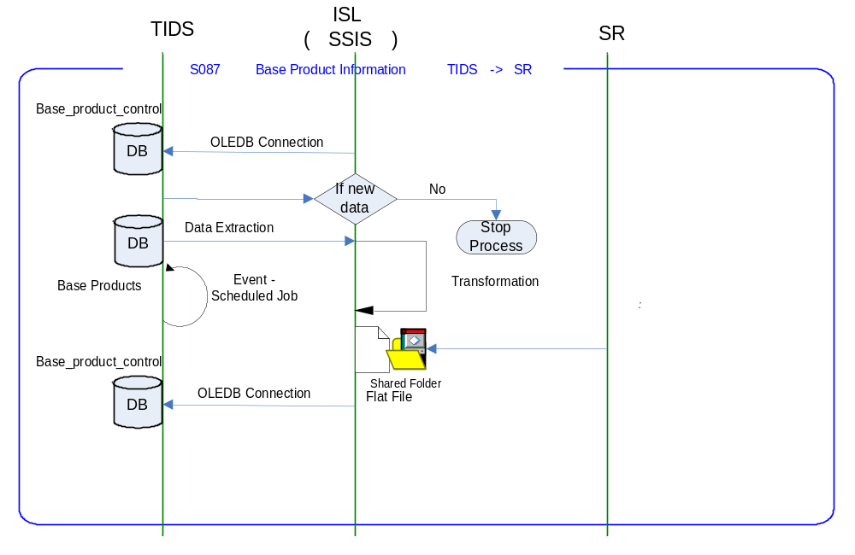

Requirements of the End-to-End Interface

The interface will run once a day, on scheduled basis, and consists of a SQL Server Integration Services package that extracts data from the TIDS and transforms it into a positional flat file format on the Integration layer to be picked up by the Store range system.

The interface will make use of the audit and traceability components that are being developed as part of the Operational Framework stream. These components will be pluggable, and will be useable from BizTalk, RTI and SSIS. At the time of writing (2007-03-01) the components are in design. Although not ready for use, they are included on the Information Architecture Context diagram where their functionality is required. Developers should put a ‘placeholder’ in their code / configurations as appropriate.

Non-Functional Requirements of the End-to-End Interface

Audit Requirements | The interface will use the components provided by the Operational Framework to satisfy audit requirements.
Security Requirements | The interface executes within a secure private domain. There is no additional security considerations required.
Timing/Cut-off Constraints | To be finalised.
Performance Requirements | The interface should be capable of extracting data from TIDS through SSIS Service layer delivering the resulting data into target schema flat file format to SR. These processes should occur before the identified cut-off time. The interface should run on scheduled batch basis.
Reliability and Availability Requirements | The interface-run should be atomic in nature. Appropriate mechanisms should be in place to raise/alert appropriate parties (TBD).
Scalability Requirements | No Scalability requirement. The requirement is to deliver a single extract. It is anticipated that the volume of data transferred will continue to remain within the capability provided by this implementation.
Operational Support Requirements | The successful delivery, failure in the creation of the extract, and failure in message transport, must be recorded by the Integration Management Operational Framework (IMOF). In the event of failure, an alert should be raised. Alerts will be monitored by HSC Operations and passed to support as appropriate. (Refer to 8.3 Outstanding Issues).
Likelihood of Change Requirements | Since this interface is developed on assumptions There will be a change for this interface is expected.
Cultural/Global Consideration Requirements | Although multi-byte character set support is not required for US or Turkey, the interface will support multi-byte character sets through integration.
Legal Requirements | N/A
Compliance To Standards Requirements | No compliance exceptions.

Processing Required in the Extract Stage of the Interface

Scope
A scheduled batch job/s runs, at a pre-configured time, to extract the Base Product data from the TIDS through OLE DB Connection by executing SQL server Integration Services package. The returned data-set will be transformed to the target flat file format within SSIS package and stored within IL. Store range will have access to the Integration layer’s Inbox of Store range system’s folder.

After successful completion of data extraction, time stamp has to be updated on the control table. Store range system will move the files to the archive folder of the application’s Archive folder on the Integration layer.

Source Message Schema
The data for this interface resides in staging table of Transaction Integration Data Store. Filter the unique records on the Staging table for SKUID

Staging Table Name: SKUItem_Staging

Field | Data type | Description
SKUID | Varchar(25)
SKUDesc | Varchar(250)
ArticleId | Varchar(25)
SupplierPackSize | Numeric(12,4)
Height | Numeric(12,4)
Width | Numeric(12,4)
Length | Numeric(12,4)
TescoBrand | Varchar(16)
DiamondInd | Char(1)
OriginalRetailPrice | Numeric(20,4)
unit_cost | Numeric(20,4)
SubClass | Smallint
Status | Char(1)
TrayPackInd | Char(1)
BuyerName | Nvarchar(250)
LastUpdateDateTime | Datetime

Message Transport Details

Feature | Specification | Additional Information
Source System Name | TIDS
Source Platform / OS | Windows 2003 Server
Source Physical Location | SQL SERVER 2005
Source Underlying Data Storage Technology | RDBMS
Target System Name | --
Target Platform / OS | Windows 2003 Server
Target Physical Location | --
Target Underlying Data Storage Technology | In Memory
Transfer Function | HTTP (Put/Post) □  HTTPS (Put/Post) □  Message Queue □  FTP □  File Drop(Windows) □  (XCOM) □  SSIS ☑
Data Format. | XML □  Delimited □  Positional □  RDBMS ☑
Decryption/Encryption | No
Decompression/Compression | No
Transmission Mode | Synchronous □  Asynchronous ☑  Bulk Data □
Real-time/Scheduled Batch | Scheduled Batch
Archiving | There is no requirement to archive the messages.
Logging | Log via the Operational Framework.
Error Handling | Not yet decided  Processing should prevent sending of duplicate messages, unless this occurs during recovery from failure.

Naming and Configuration

SSIS
Package Name: TOM.S087.TIDStoSR.BaseProducts.dtsx
SSIS Procedure
Name | S087_GetBaseProducts_usp.sql
<Placeholder for other package components/steps>
<Placeholder for other package components/steps>

Environment and Security Context

This section should contain any additional environment specific details deemed necessary. The information will depend on the technologies used by the interface. For example employing BizTalk this section would include details of the host – In-Process Host, Isolated Host, and whether the host was Trusted/Untrusted. For interfaces employing the RTI indicate whether the instruction is Hosted/Unhosted.

Also indicate the account that the process will run under. In projects where the target deployment environment does not exist at the time of writing the interface specification, the information should be added at a later date (but obviously, prior to deployment).

Account details will be included here once we have visibility of the environments.

Non-Functional Requirements

This section should contain any non-functional requirements pertaining to this stage of the interface.

Processing Required in the SSIS Stage of the Interface for SR

Scope
This section describes the discrete steps within the SSIS package to extract and format data. The target schema is included in this section. This segment will process the data picked from TIDS and transform into target flat file message schema in Integration layer. The data will be stored in the Store range’s Inbox to let the Store range system to access the same. Once the file is read, SR will move the file to the Archive directory of IL

Package Overview
SSIS extracts the Base Products data from TIDS via SQL Server using OLEDB connection, at a predefined time. In turn, the data is transformed into a target flat file message schema in Integration layer.

Data Validation
N/A.

Filtering
There is no filtering requirement.

Mapping
Mapping document will be provided subsequently.

Target Message Schema

Flat file Name: S087_TIDS_BaseProducts_ YYYYMMDDHH24miss.txt (TBC)

Field | Description | Format
Header Record |  | Len 146
HeaderRECTYPE | Value ‘0’ | Char(1)
RUNDATE | YYYY-MM-DD | Char(10)
RUNTIME | HHMMSS | Char(6)
FILLER |  | Char(129)
Detail Record |  | Len 146
DetailRECTYPE | Value ‘1’ | Char(1)
Product |  | Integer(25)
ProductDescription |  | Char(120)
Trailer Record |  | Len 146
TrailerRECTYPE | Value ‘9’ | Char(1)
RECCOUNT |  | Char(9)
FILLER |  | Char(136)

Message Transport Details
For messages destined for IDS (from SR in Integration layer), the following applies.

Feature | Specification | Additional Information
Source System Name | --
Source Platform / OS | Windows 2003 Server
Source Physical Location
Source Underlying Data Storage Technology
Target System Name | IL (SR)
Target Platform / OS | Windows 2003 Server
Target Physical Location | SR/Inbox
Target Underlying Data Storage Technology | RDBMS
Transfer Function | HTTP (Put/Post □  HTTPS (Put/Post) □  Message Queue □  FTP □  File Drop (Windows) ☑  (XCOM) □  RTI File Adapter □  SSIS □
Data Format | XML □  Delimited □  Positional ☑  RDBMS □
Decryption/Encryption | No
Decompression/Compression | No
Transmission Mode | Synchronous □  Asynchronous ☑  Bulk Data □
Real-time/Scheduled Batch | Scheduled Batch
Archiving | N/A
Logging | Log via the Operational Framework.
Error Handling | Not yet decided

Processing Required in the SSIS Stage of the Interface for TIDS

Scope
This section describes the discrete steps within the SSIS package to update the latest datetime stamp on the TIDS Control table to denote the success.

Package Overview
SSIS extracts the Base Products data from TIDS via SQL Server using OLEDB connection, at a predefined time. In turn, the data is transformed into a target flat file message schema in Integration layer. The latest time stamp will be updated in the control table against the interface.

Data Validation
N/A.

Filtering
There is no filtering requirement.

Mapping
No mapping document is provided as the values to be updated are straightforward

Target Message Schema

Table Name: base_product_control

Field | Data type | Description
RowId | Integer | Serial Number
Component | Varchar(10) | Interface Number
LastRunDt | Varchar(14) | Last run date and time in YYYYMMDDHH24MISS format

Message Transport Details
For messages destined for TIDS (from Integration layer), the following applies.

Feature | Specification | Additional Information
Source System Name | --
Source Platform / OS | Windows 2003 Server
Source Physical Location
Source Underlying Data Storage Technology
Target System Name | TIDS
Target Platform / OS | Windows 2003 Server
Target Physical Location | Base_product_control
Target Underlying Data Storage Technology | RDBMS
Transfer Function | HTTP (Put/Post □  HTTPS (Put/Post) □  Message Queue □  FTP □  File Drop (Windows) □  (XCOM) □  RTI File Adapter □  SSIS ☑
Data Format | XML □  Delimited □  Positional □  RDBMS ☑
Decryption/Encryption | No
Decompression/Compression | No
Transmission Mode | Synchronous □  Asynchronous ☑  Bulk Data □
Real-time/Scheduled Batch | Scheduled Batch
Archiving | N/A
Logging | Log via the Operational Framework.
Error Handling | Not yet decided

Testing Deliverables
This section should contain a list of discrete deliverables. The following table is an illustrative template only. The exact deliverables will depend on the technologies employed in the interface.

Deliverable | Description
TBD <stored proc name> | Stored Procedure
TBD <stored proc name> | Stored Procedure
TBD <service name>
TBD <SSIS package name> | Package
TBD <script name> | Unit Test Scripts. Scripts should be provided to:  - Create databases (including stored procedures).  - populate with the minimum set of test data to satisfy functional requirements  - notes showing how to use scripts and describing the functions tested.
<installer> | Installers as appropriate to the technology being used.

Deployment

Assumptions and Outstanding Issues

Assumptions
ID | Assumption
1. | The Output file name has to be confirmed from the Store range system

Outstanding Issues
ID | Issue | To be addressed by
1 | Timings and cut-off constraints need to be defined. Require input from SR | SA
2 | Alert numbers/identifiers are yet to be defined | SA
3 | The design of the IMOF is still being worked and will require retro-fitting to the interface. | IMOF team

- Volumes
- Glossary

Acronym | Term | Description
EAI | Enterprise Application Integration | The process of meeting the data requirements of applications by providing a message based transport from disparate data sources across all forms of enterprise technology.
EAI Layer | Enterprise Application Integration Layer | Refers to the integration services provided to implement EAI. In contrast to the EIA Layer for data services. See below.
EIA | Enterprise Information Architecture | Creation of a strategic single view of data across the enterprise.
Interface | Interface | Many definitions exist for 'interface'. In general, 'interface' refers to the link between a data source and a data target. And there are properties of the interface in this context. However more specifically 'interface' refers to one end of a data link, hence the terms source interface and target interface, and both the source interface and the target interface will have specific properties of their own.
RMS | Retek Merchandising System | Retek Merchandising System is getting installed for TESCO Merchandising operations in US. This system will governs the Merchandising operations; Receive base Master & Transaction data and from other systems and Provide data to next level of operation system as part of Retail systems chain.
PP | Product Position | SQL Server Database provided by Product position which captures the capacity information for the products which are not part of planogram
IKB | Intactix Knowledge Base | SQL Server Database provided by JDA Intactix to maintain Space Planning and Floor Planning data.
IMOF | Integration Management Operational Framework | IMOF is a framework which is pluggable to any Biztalk, RTI and SSIS for alerting, exception handling, defining rules, scheduling etc

- Document Control
Change Record

Author | Date | Version | Change Reference, description
Prasanth Dukaram | 18-May-2007 | 0.1 | Draft
Debasis Pattanaik | 15-06-2007 | 0.2 | Draft – Modified to incorporate CR084

Related Documents

Author | Date | Version | Title
Clive Mizen | 25/04/2007 | 1.1 | Store Range TSD 1.1

Distribution

Name | Position | Approver/Contributor/Other
Jon Braggs | Enterprise Architect
Andrew Barker | Solution Architect
Mary Welch | Manager – SRD TOM project

